Here for packer, we need to define Its configuration in json format.

there were three main building block for packer config:-
- Builders
- Provisioner
- Post Processors

First we will deals with builders.

Lets go to HashiCorp Packer website and see docs about builders.

goto builders --> overview --> this will tell you about builders.

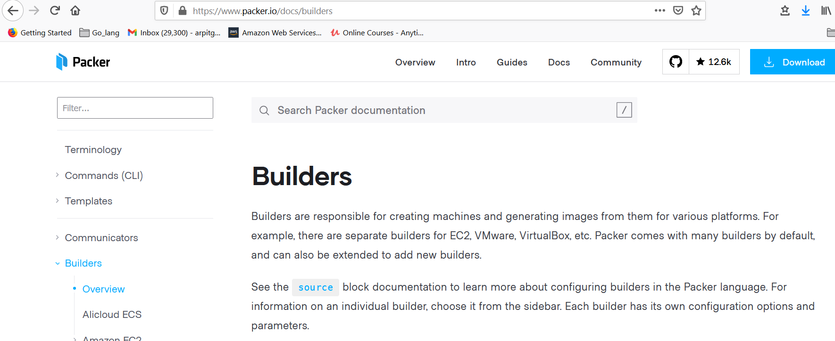

Builders are responsible for creating machines and generating images from them for various platforms. For example, there are separate builders for EC2, VMware, VirtualBox, etc. Packer comes with many builders by default, and can also be extended to add new builders.

See the source block documentation to learn more about configuring builders in the Packer language. For information on an individual builder, choose it from the sidebar. Each builder has its own configuration options and parameters.

So there were different builders for different platform.

in project1 directory create one json file lets say example.json, now start configuration:-

Packer support multiple of builder in a single file.

So packer field in json is list so that we can mention more that one builder.
like we want identical image with same configuration, build over AWS, Azure, GCP and other so we need to put that into builders list.

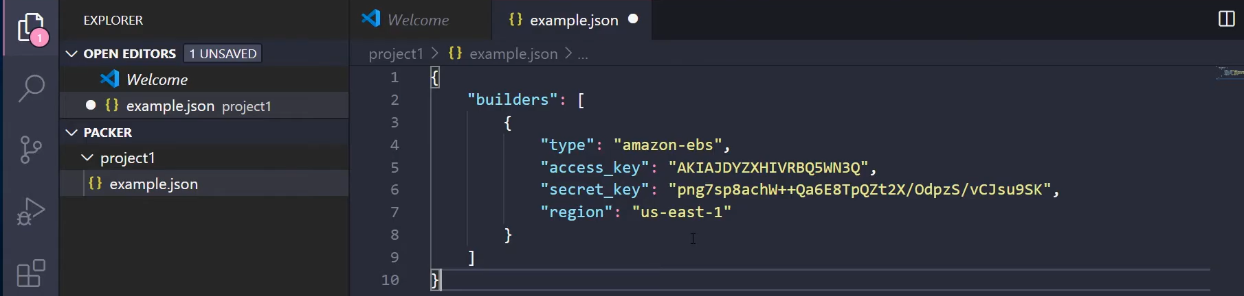

here we use only one builder "amazon-ebs".

we also need to define our baremetal image, like in case of AWS EC2 -- AMI called "amazon linux",
this is baremetal, Also we need to define instance type like t2.micro, this is because your image need to be run as a instance then we can do all config, then it will converted to the image.
and when image is build this will automatically destroy.

now once our EC2 instance is create packer also need to access that EC2 to run configuration.
we can give ssh username and password.

so the base configuration is like:-

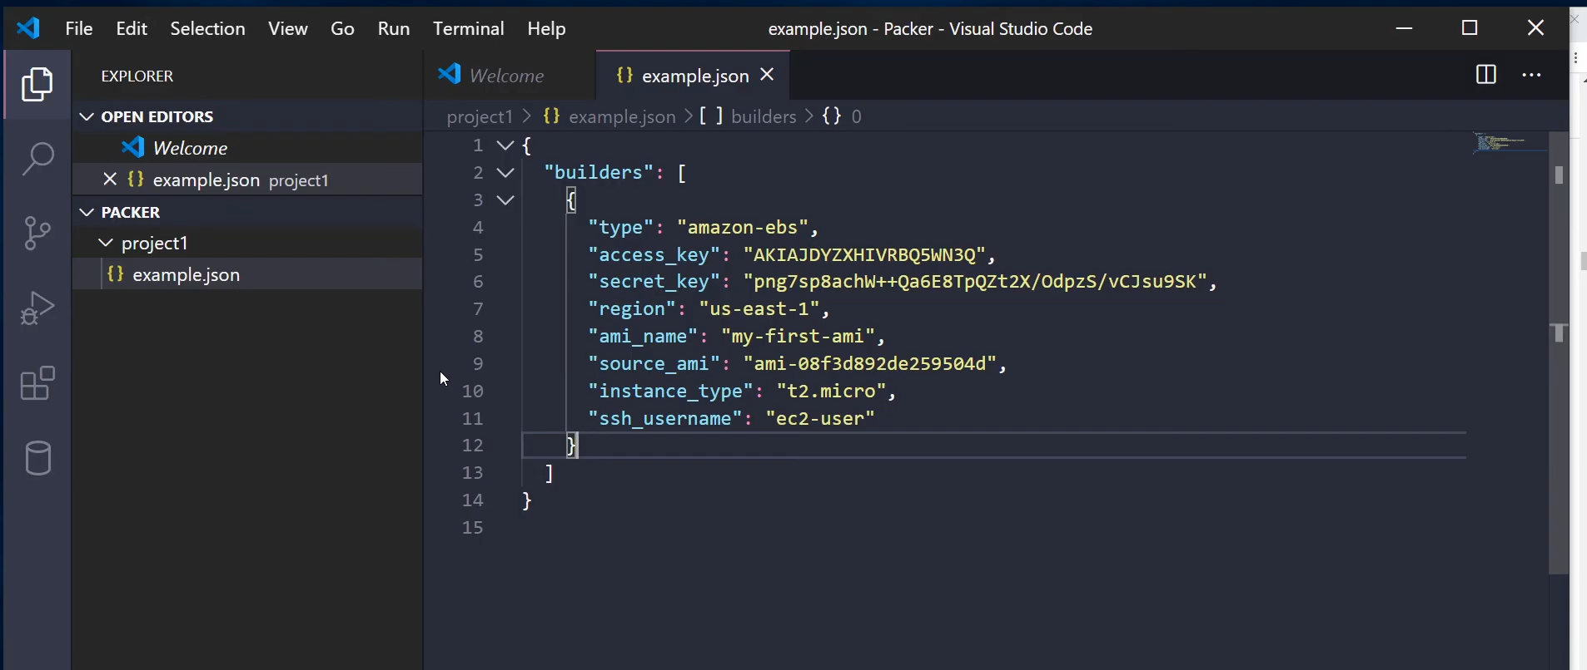
still here we have provide any configuration yet, but by building this it well create image very similar to "amazon-linux"

then command > packer build example.json

Now we will talk about provisinors so that can we apply our custom setting.

Configure provisioners :- here actually costumizability comes into play.

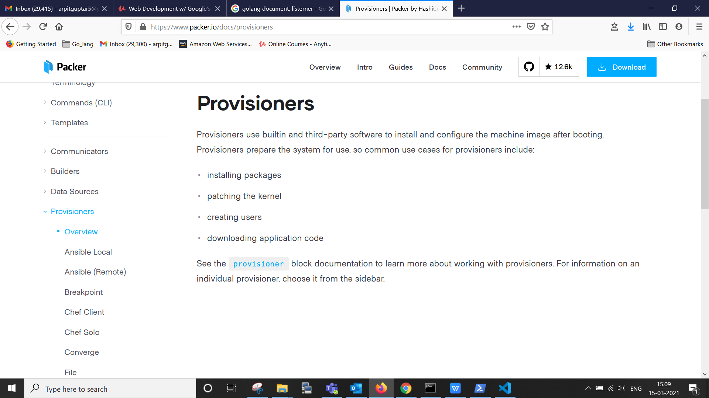

Provisioners

Provisioners use builtin and third-party software to install and configure the machine image after booting. Provisioners prepare the system for use, so common use cases for provisioners include:

- installing packages
- patching the kernel
- creating users
- downloading application code

See the provisioner block documentation to learn more about working with provisioners. For information on an individual provisioner, choose it from the sidebar.

like configuration, firewall, setups, python code and almost everthing we can push to our running instance so that, provision take place.

there are provisioner like Ansible, shell, chef and other, we are going to use Shell. because this one is most basic and mostly used.

we can use multiple provisinors for single image. So that why it is of type "json list"
so we can use shell, Ansible, puppet and other all in one go.

as type is shell, inline property is acts like json list so we can run multiple of shell command on it.

we can apply sleep 30 , in inline first so just to staf safe whether OS is completely boots or not.

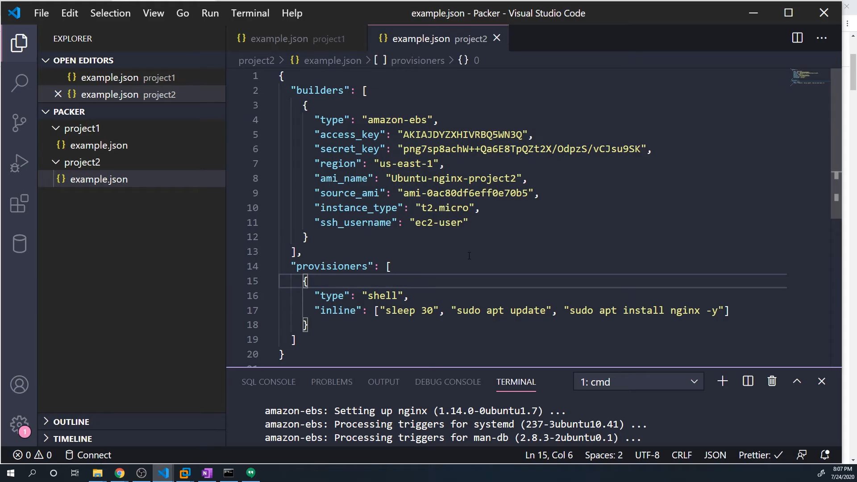

so this is all we need to take an ubuntu image into AWS and build an custom image.

> packer build example.json

